**VNET Peering between East US & South East Asia**

The architecture that is intended to be achieved in given below:

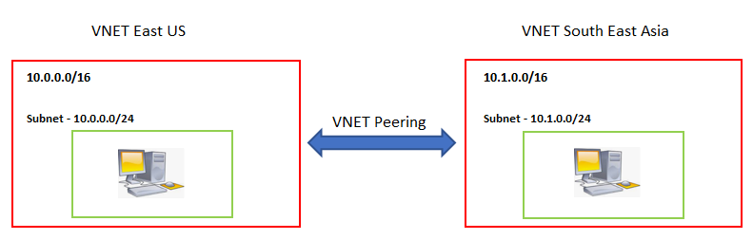

1. Create Virtual network for East US & South East Asia
2. Create Subnet within each Virtual network
3. Create VMs - VMEastUS and VMSEAsia for East US and South East Asia respectively.
4. Ping between VMs and check if they respond to each other . (Normally it will not)
5. Establish VNET peering between 2 VNets using “Peering” option
6. Ping between VMs and check if they respond to each other . (It will respond)